Pet App (Working Name)

Functional Design Specifications Document

Created: 3/10/2014

Revised: 3/10/2014

Contents

1. Application Abstract 2

1.1 Features 2

1.2 Market Features 2

1.3 Fiscal Goals 2

1.4 Business Goals 2

2. Application Details 3

2.1 General Feature List 3

2.2 Screens 3

Home Screen 3

Settings Screen 3

New Pet Profile Screen 3

Pet Activities Screen 4

Pet Activity Notification Screen 4

Pet Activity History Screen 4

2.3 Screen Flow Chart 4

3. Graphics and Art Style 5

4. Sound 6

5. Development Load & Resources 7

5.1 Team Members & Responsibilities 7

# Application Abstract

## Features

The purpose of the application is to facilitate with the tracking of pet activities such as taking a pet out for a walk, feeding them, or letting them out to pee. The app will have the ability to store all of the important pet activities, be they recurring or one-offs.

With the simple logging of activities, the entire family can be updated on all pet activities. This will eliminate the occurrence of "accidents" in the house hold. This will eliminate the wondering if the pet was fed or not.

## Market Features

Application will be initially developed for the Android platform. Key market features include a very easy to use interface which will ensure that the typical activity logging use case for the end-user takes but a few seconds to complete. User-interface should be appealing and elegant, while maintaining ease of use and functionality as its key drivers. Application should be very light so that loading times are kept to a minimum.

## Fiscal Goals

Application will be released as a “free” (ad-supported), with the plan to release a paid, ad-free version (price to be determined). Any and all profits will be split evenly amongst all team members.

## Business Goals

Initial release of the application will target only the Android platform. Future releases will target the iPhone platform. After both versions of the application are released, they will both be supported and maintained, provided there is enough of an existing user-base to justify the time investment from team members.

The application will be marketed via aggregation sites such as reddit, and social media sites like Facebook, YouTube, and Twitter.

# Application Details

## General Feature List

The following list will be appended to track features in past, current, and future releases.

Version 1.0 Key features include:

* A very simple and fast interface
  + This will be important to attract customers and make the app be as useful and least time consuming as possible.
* Notifications can be set to remind users when a pet activity needs to be done
  + These notifications will be flexible in their configuration in terms of when they will trigger.
  + An alert can be setup to trigger in any combination of the following ways:
    - On a given day or days of the week (eg: Saturday, Sunday, Wednesday)
    - For a given time of the day range (eg: 7AM-9PM)
    - Every X number of hours or minutes (eg: every 2 hours or every 45 minutes)
  + Notification message will have a "Done" button, and a "Snooze" button
* Ability to create profiles for multiple pets
  + Profile will store info about the pet (name, picture(s), pet type, breed, etc.)
  + Profile will also store the activity and notification/alert information and schedule for a given pet
* Ability to “check-off” when a given activity is completed
* Activity history tracking with ability to quickly view recent activities
* Ability to “undo” a completed activity
* Ability to cycle through pets using swipe left/right functionality from the home screen
* Ability to access settings by swiping from the outside top left of the screen to the right, or pressing the top left “settings” icon

Version 2.0 Key features include:

* User account functionality
* Ability to share pet profiles (including activities and notifications) across different accounts
* Synchronization functionality of shared pet profiles to show when an activity was already completed by another user

## Screens

### Home Screen

List of pets, along with the possible activities of each pet. Tile showing the list of pets, after clicking the pet tile, the list of possible activities will appear in checkbox form for the user to select.

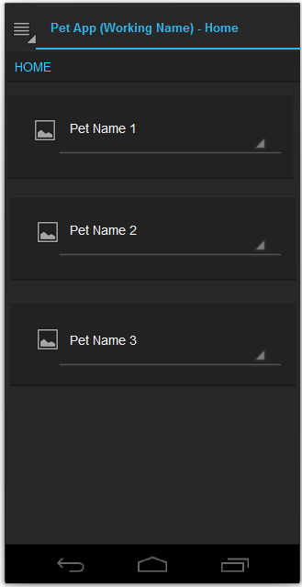

### Menu

Will contain the following options and will be available from every screen:

* Home
* Pet Setup (will be start screen when there's no Pets defined)
* Activity History
* Settings

### Pet Setup Screen

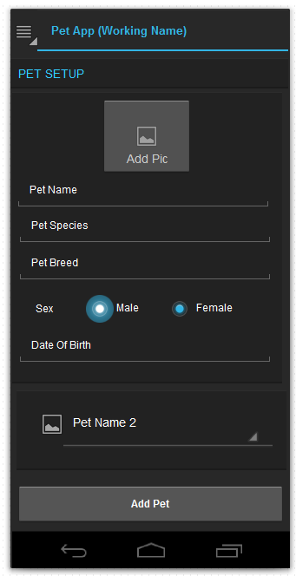

### Pet Activities Screen

To do

### Pet Activity Notification Screen

To do

### Pet Activity History Screen

To do

### Settings Screen

To do

## Screen Flow Chart

To do

# Graphics and Art Style

To do

# Sound

To do

# Development Load & Resources

## Team Members & Responsibilities

There will be no minimum or maximum amount of hours to be worked on a daily or weekly basis, however, “by whens” must be assigned to all identified activities and tasks in order to move the project along.

Team Members:

* Adrian Alfonso – Project Manager, Designer
* Luis Rizo – Project Manager, Designer, Developer
* TBD – Designer, Art Director